PUPIL NAME:……………………………………………………………………………………………………

Name the following fossils pictured below
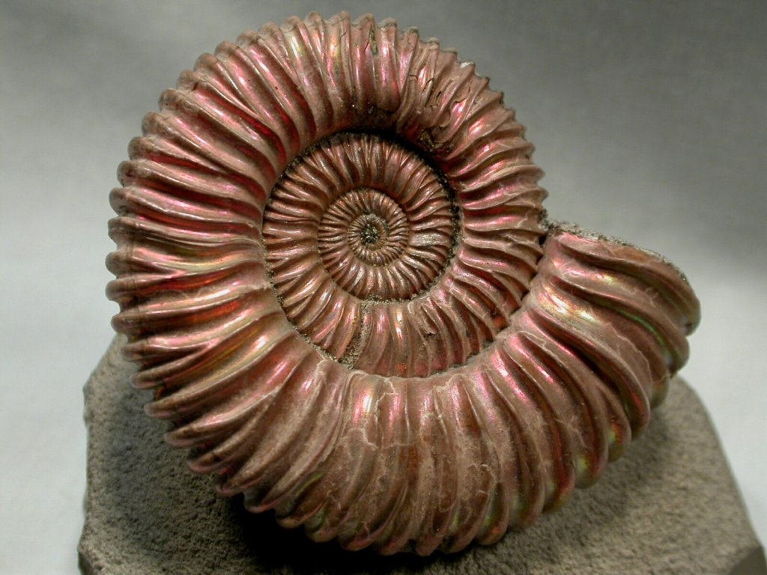 | …………………………. | 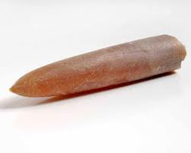 | ………………………..
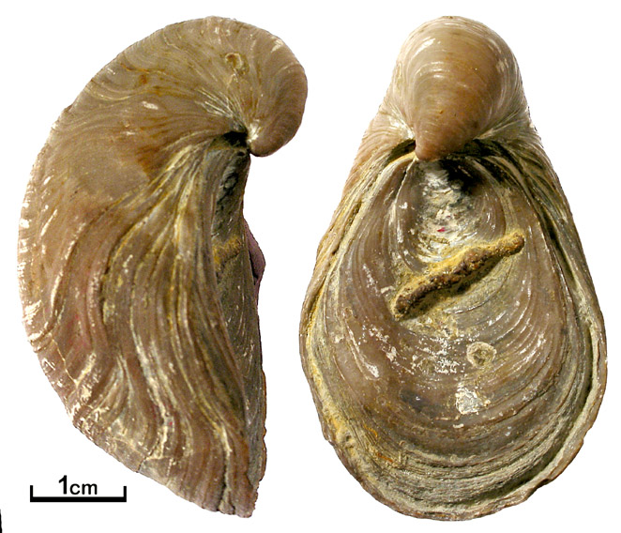 | ………………………… | 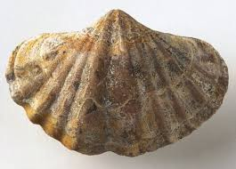 | ………………………..
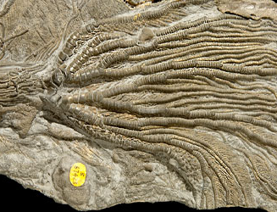 | ………………………….

What can these fossils tell us about the rock that they are found within?

…………………………………………………………………………………………………………………………………………

…………………………………………………………………………………………………………………………………………

…………………………………………………………………………………………………………………………………………

The large quarry is known as a SSI. What does this mean? What are you unable to do here?

……………………………………………………………………………………………………………………………………..

………………………………………………………………………………………………………………………………………

……………………………………………………………………………………………………………………………………....

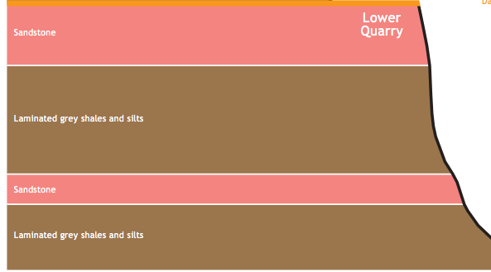
This picture shows the alternating layers of rock in the lower quarry. Have a close look at the different layers at the site.

What differences can you see between the different layers of rock?

…………………………………………………………………………………………………………………………………………

…………………………………………………………………………………………………………………………………………

…………………………………………………………………………………………………………………………………………

…………………………………………………………………………………………………………………………………………

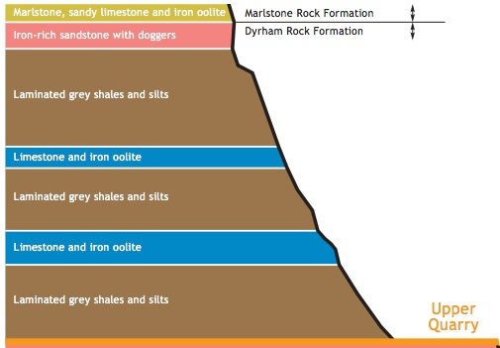
This is a diagram of the Upper Quarry.

What is the youngest rock: Grey shales, marlstone or Iron rich sandstone?

………………………………………….

What is the Oldest Formation:
Marlstone or Dyrham?

…………………………………………..

These rocks are from the Jurassic period? Approximately, how old are these rocks?

…………………………………………………………………………………………………………………………..

Around the base of the cliffs, you may see many loose rocks and scree as in the below picture:

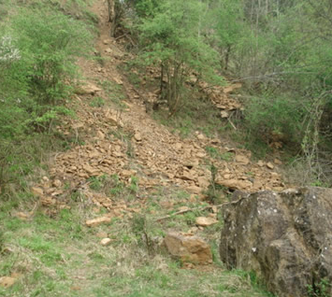
What do you think causes the rocks to become loose and to fall down?

………………………………………………………………………………….

………………………………………………………………………………….

…………………………………………………………………………………

………………………………………………………………………………………………………………………………………

………………………………………………………………………………………………………………………………………

